BY: DIMPLE SHARMA
KARAN SINGH
DIVYA V

HOTEL REVENUE ANALYSIS PROJECT
POWER BI PROJECT
PROJECT STATEMENT

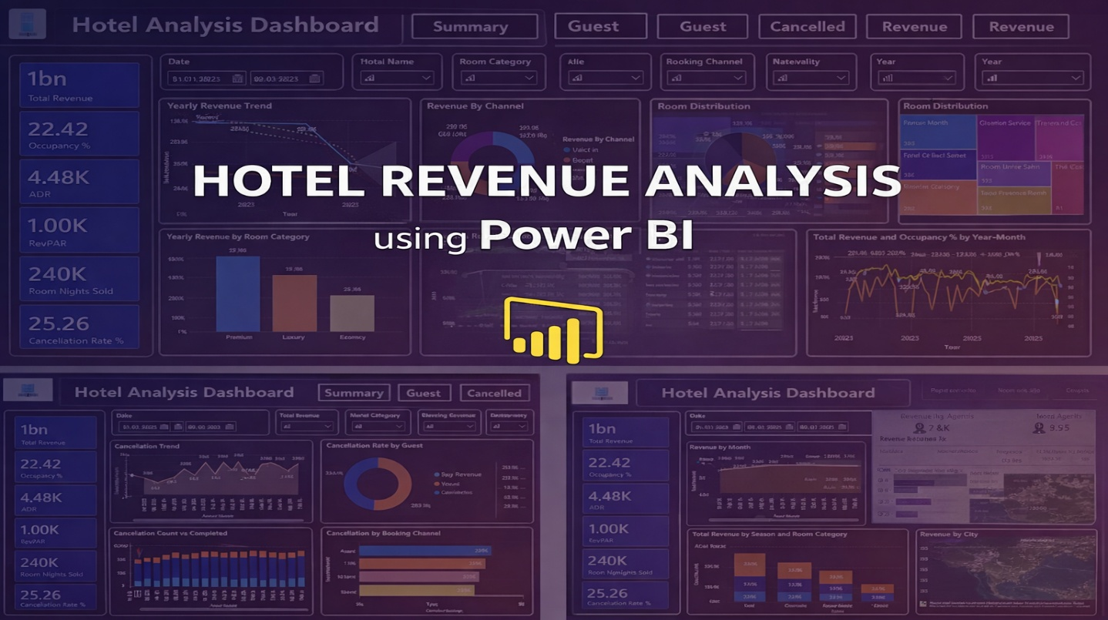

Hotels must understand their occupancy patterns, guest demographics, and pricing effectiveness to improve revenue. This project builds an analytical solution in Power BI to track room bookings, average daily rates, guest profiles, and seasonal trends. It helps hotel management make decisions around promotions, upselling, pricing strategies, and room optimization.

OUTCOMES:
• Occupancy rate and booking trend dashboards
• ADR (Average Daily Rate) and RevPAR (Revenue Per Available Room) metrics
• Customer segmentation by stay purpose and demographics
• Forecasting of occupancy and revenue based on historical data
• Branch-level performance comparisons
• Strategic dashboard for pricing and marketing actions
• Model scalability across hotel chains and geographies

HARDWARE AND SOFTWARE REQUIREMENTS

The Hotel Revenue Analysis project requires a standard system capable of handling data modeling and visualization using Power BI.
Hardware Requirements
- Processor: Intel i3 / AMD equivalent or higher.
- RAM: Minimum 4 GB (8 GB recommended).
- Storage: At least 10 GB free space.
Software Requirements

Microsoft Power BI Desktop – for data modeling and dashboard development.
- Microsoft Excel – for data preparation.
- Operating System – Windows 10 or higher.

MODULES

- Data Modeling and Ingestion
1.1 Load booking, customer, and room data
1.2 Build Star Schema (Date, Room, Customer, Hotel Branch)
1.3 Calculate booking duration, room category, and stay type
- Occupancy & Revenue Metrics
2.1 Occupancy %, ADR, and RevPAR analysis
2.2 Daily, weekly, and seasonal performance visualization
2.3 Comparison of Direct bookings and OTA bookings
- Guest Analysis Module
3.1 Analysis of guest types (Business, Family, Solo)
3.2 Nationality, booking source, and stay duration analysis
3.3 Customer segmentation (First-time, Loyal, High Spenders)
- Forecasting and Cancellation Trends
4.1 Occupancy forecasting using trend analysis
4.2 Cancellation rate and lead time distribution
4.3 No-show and refund trend analysis
- Revenue Strategy Dashboard
5.1 Identification of upsell opportunities
5.2 Pricing recommendations by season and room type
5.3 Final interactive dashboard for management

DATA MODELING AND INGESTION

Introduction
Data modeling and ingestion form the foundation of the Hotel Revenue Analysis project. This module integrates raw hotel data from multiple sources and structures it into an optimized analytical model in Power BI. The objective is to load booking, customer, room, and hotel branch data, build a Star Schema model, and create calculated attributes such as booking duration, room category, and stay type. A well-structured model ensures accuracy, scalability, and better performance.

Data Sources
The project uses the following datasets:
- Booking Data: Booking ID, check-in/out dates, channel, total amount, nights
- Customer Data: Customer ID, nationality, guest type, stay purpose
- Room Data: Room ID, type, category, total rooms
- Hotel Branch Data: Hotel ID, city, region, hotel name
- Date Table: Year, quarter, month, season
Data is cleaned and transformed in Power BI using proper data types and removal of duplicates/null values.

Star Schema Model
A Star Schema is implemented with:
- Fact Table: Bookings
- Dimension Tables: Date, Room, Customer, Hotel Branch
This reduces redundancy and improves report performance using defined relationships (Primary & Foreign Keys).

Key KPIs
- Total Revenue: 1.07 bn
- Occupancy %: 22.42%
- ADR: 4.48K
- RevPAR: 1.00K
- Room Nights Sold: 240K
- Cancellation Rate: 25.26%
These KPIs provide a quick overview of hotel performance.

Calculated Fields
- Booking Duration: Difference between check-in and check-out
- Stay Type: Short (1–2), Medium (3–5), Long (>5 nights)
- Room Category: Standard, Deluxe, Premium
- Total Rooms & Total Revenue: Used for occupancy and financial analysis

Slicers Used:
Slicers: Date, Hotel Name, Room Category, Booking Channel, Nationality, Year

Visuals Used:
- Treemap – Revenue By City
- Bar Chart – Revenue by Room Category
These visuals support strategic pricing and capacity planning.

Key Insights
- Star schema improves performance.
- Premium rooms generate highest revenue.
- Higher capacity branches show stronger infrastructure.
- Clean modeling ensures accurate KPI calculations.

OCCUPANCY & REVENUE METRICS

Introduction
Module 2 evaluates hotel performance using key occupancy and revenue metrics. It transforms raw booking data into actionable KPIs such as Occupancy %, ADR (Average Daily Rate), and RevPAR (Revenue per Available Room). These metrics help management track operational efficiency, pricing effectiveness, and revenue optimization. The Power BI dashboard provides both summary-level and detailed trend analysis across time and booking channels.

Calculated Measures & Attributes
- Booking Channel: Classifies reservations as Direct, Walk-in, OTA, or Agent to analyze channel performance and profitability.
- Upsell Potential: Identifies additional service opportunities such as Spa, Dining, or Combo packages to increase booking value.
- Occupancy %: DIVIDE([Room Nights Sold],[Total Rooms] * [Total Days]) * 100; measures capacity utilization.
- Total Revenue: Sum of booking amounts; evaluates overall financial performance and growth.

Visuals Used
- Yearly and Monthly Revenue Trend (Line Chart): Shows revenue performance over time; recent decline indicates possible operational or market challenges.
- Revenue by Channel (Donut Chart): Displays revenue distribution among Direct, Walk-in, OTA, and Agent channels; shows balanced performance.
- Booking Count by Upsell Potential (Funnel Chart): Highlights cross-selling opportunities, with Spa & Dining showing highest bookings.
- Revenue & Occupancy % by Month (Dual Axis Line Chart): Demonstrates strong correlation between occupancy levels and revenue growth.

Key Insights
- Revenue growth is closely linked to occupancy levels.
- Direct bookings generate higher profitability.
- Seasonal trends significantly impact occupancy and RevPAR.
- Recent revenue decline suggests demand or operational challenges.

GUEST ANALYSIS MODULE

Introduction
The Guest Analysis Module evaluates guest behaviour, booking preferences, revenue contribution, and occupancy impact. By analysing guest types, booking channels, nationality, stay duration, and customer segmentation, this module helps hotels identify high-value customers and improve retention strategies. The insights support personalized services, targeted marketing, and revenue optimization.

Calculated Measures & Attributes
- Stay Purpose: Categorizes bookings as Business or Leisure to analyze demand patterns and pricing strategies.
- Nationality: Identifies guest origin to understand international demand and regional market performance.
- Average Stay Duration: Calculates average nights per booking; helps identify long-stay opportunities and revenue optimization.
- Customer Segment: Classifies guests as Loyal, Regular, or First-Time based on booking frequency and revenue contribution to support loyalty and retention strategies.

Visuals Used
- Upsell Potential (Key Influencers): Identifies main factors that influence upselling opportunities such as stay type and customer segment.
- Nationality Revenue Heatmap (Matrix): Displays revenue contribution by nationality across Business and Leisure categories.
- Booking Channel Preference (Stacked Bar Chart): Compares channel usage across guest types; Direct and OTA channels show strong performance.
- Customer Segmentation (Donut Chart): Shows revenue share by guest segment; Loyal guests contribute the most.
- Total Revenue by Guest Type (Bar Chart): Highlights highest revenue generation from Loyal guests.

Key Insights
- Loyal guests contribute the highest revenue and form the largest segment.
- Direct and OTA channels are preferred across Business and Leisure bookings.
- Long stay guests have higher upsell potential, creating opportunities for targeted offers.
- Occupancy and ADR together drive strong RevPAR performance.

FORECASTING & CANCELLATION TRENDS

Introduction
The Forecasting & Cancellation Trends Module analyses booking reliability, cancellation behaviour, and revenue loss patterns. It helps hotel management understand cancellation trends, seasonal impact, and booking channel risks. By examining cancellation rates, refund amounts, and booking status distribution, this module supports proactive decision-making to reduce revenue leakage and improve operational planning. It also assists in identifying potential financial risks before they affect overall revenue performance.

Calculated Measures & Attributes
- Status: Categorizes bookings as Completed, Cancelled, or No-Show to evaluate booking performance and revenue realization.
- Stay Purpose: Classifies bookings as Business or Leisure to analyse cancellation behaviour across segments.
- Cancellation Rate %: (Cancelled Bookings ÷ Booking Count) × 100; measures booking reliability and policy effectiveness.
- Total Refund: Sum of refunded amounts due to cancellations; helps assess financial impact and revenue loss.

Visuals Used
- Cancellation Trend (Line Chart): Shows monthly cancellation rate fluctuations and identifies abnormal spikes.
- Cancellation by Stay Purpose (Donut Chart): Compares Business and Leisure cancellations; both segments contribute significantly.
- Revenue Lost Due to Cancellation (Column Chart): Displays monthly financial loss caused by cancellations.
- Cancellation Count vs Completed (Stacked Column Chart): Compares completed, cancelled, and no-show bookings to highlight revenue gaps.
- Cancellation by Booking Channel (Bar Chart): Identifies high-risk channels requiring improved cancellation policies.
- Cancelled Bookings by Season (Decomposition Tree): Analyzes seasonal cancellation trends with drill-down options for channel, room category, and customer segment.

Key Insights
- Cancellation rate remains high, affecting occupancy stability.
- Revenue loss due to cancellations is consistent across months.
- Peak season shows higher cancellation volume.
- Different booking channels show varying cancellation behavior.
- Noticeable gap exists between completed and cancelled bookings.
- Continuous monitoring improves forecasting and revenue planning.

REVENUE STRATEGY DASHBOARD

Introduction
The Revenue Strategy Dashboard analyses total revenue performance, pricing efficiency, seasonal contribution, and geographic distribution. It enables hotel management to evaluate key revenue drivers, understand the impact of ADR (Average Daily Rate), and identify high-performing segments across seasons and cities. By integrating KPIs, trend analysis, and booking channel insights, this module supports data-driven revenue optimization and strategic planning.

Derived Columns & Measures
- Stay Type: Classifies bookings as Business or Leisure to analyse demand behaviour and pricing strategies.
- Room Category: Categorizes rooms as Standard, Deluxe, or Premium to study occupancy trends and pricing impact.
- ADR (Average Daily Rate): Total Revenue ÷ Room Nights Sold; measures pricing efficiency and revenue per occupied room.
- Total Revenue: Sum of booking amounts; evaluates overall financial performance and growth.

Visuals Used
- Revenue by Month and Quarter (Line Chart): Shows monthly revenue trends with moderate seasonal fluctuations.
- ADR vs Suggested ADR (Clustered Column Chart): Compares actual ADR with suggested ADR to evaluate pricing performance.
- Revenue by Hotel Name (Decomposition Tree): Provides drill-down analysis of hotel-wise revenue contribution.
- Occupancy vs ADR (Line chart): Displays the relationship between occupancy rate and the ADR.
- Revenue by Stay Type (Funnel Chart): Shows long-stay bookings generate the highest revenue.
- Revenue by Nationality (Map Visual): Displays revenue contribution from different nationalities across various region.

Key Insights
- Revenue remains unstable with seasonal variations.
- Revenue varies across different hotels, showing differences in performance.
- ADR and occupancy trends fluctuate across months, indicating seasonal demand patterns.
- Long-stay bookings contribute significantly to profitability.
- Revenue varies by nationality, showing regional demand differences.
- Comparison between ADR and Suggested ADR helps evaluate pricing effectiveness.
ARCHITECTURE DESIGN

Introduction
The Hotel Revenue Analysis system is designed using a layered Business Intelligence (BI) architecture in Power BI. This architecture ensures a smooth and structured flow of data from operational systems to interactive dashboards used by hotel management. The design focuses on data accuracy, performance optimization, scalability, and effective decision-making.
Data Source Layer
The architecture begins with the Data Source Layer, which collects raw hotel data from systems such as the Booking Engine, Hotel CRM, Online Travel Agencies (OTA), Channel Managers, and Excel/CSV files. This data includes booking details, customer information, room data, revenue records, and seasonal trends.
Data Transformation Layer (ETL)
The collected data is processed using Power Query, where the ETL (Extract, Transform, Load) process is performed. During this stage, data cleaning, removal of duplicates, handling of missing values, data type correction, and creation of derived fields such as Booking Duration, Stay Type, and Room Category are completed. This ensures structured and reliable data for analysis.
Data Modeling Layer
After transformation, a Star Schema model is implemented. The central Fact Table (Bookings) is connected to Dimension Tables such as Date, Customer, Room, and Hotel Branch using defined relationships. This modeling technique improves query performance and enables efficient filtering across dashboards.
Analytics & KPI Layer
In this layer, DAX measures are created to generate key performance indicators including Total Revenue, Occupancy %, ADR, RevPAR, Cancellation Rate %, and Total Refund. These measures convert raw data into meaningful business metrics.
Visualization & Reporting Layer
Finally, interactive dashboards are developed in Power BI using KPI cards, line charts, bar charts, treemaps, and map visuals. Slicers allow users to filter data by date, hotel branch, booking channel, room category, and nationality. These dashboards help management monitor performance, optimize pricing, and improve revenue strategies.
Overall, the architecture ensures efficient data processing, accurate KPI calculation, and data-driven decision-making for hotel revenue management.
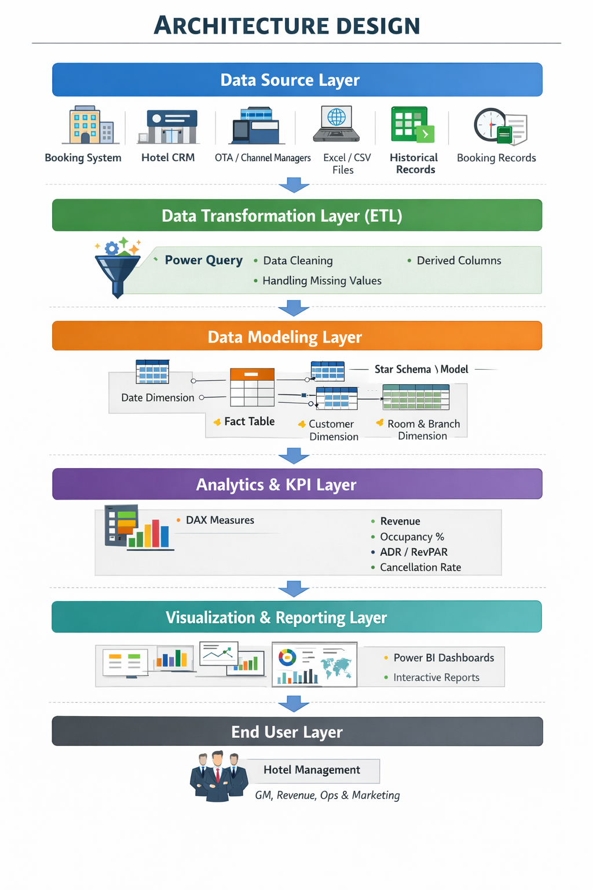

CONCLUSION

The Hotel Revenue Analysis project demonstrates how Business Intelligence tools like Power BI can transform raw hotel booking data into meaningful and actionable insights. Through a structured analytical approach, the system integrates data modeling, occupancy analysis, guest behaviour evaluation, cancellation forecasting, and revenue strategy development into a unified decision-support solution.
The Data Modeling and Ingestion phase establishes a strong analytical foundation by implementing a clean data transformation process and an optimized star schema model. The Occupancy & Revenue Metrics component converts transactional data into key performance indicators such as Occupancy %, ADR, and RevPAR, enabling effective performance monitoring. The Guest Analysis Module provides deep insights into customer segmentation, booking preferences, and revenue contribution, supporting personalized marketing and retention strategies. The Forecasting & Cancellation Trends analysis helps identify booking volatility, reduce revenue leakage, and improve operational planning. Finally, the Revenue Strategy Dashboard integrates all insights into a comprehensive view that supports pricing optimization, seasonal analysis, and geographic performance evaluation.
Together, these components create a complete data-driven decision-making system for hotel management. The project enhances visibility into revenue drivers, improves forecasting accuracy, strengthens cancellation control, and supports strategic pricing decisions. Overall, the solution contributes to improved operational efficiency, increased profitability, and smarter revenue management in the hospitality industry.

FUTURE ENHANCEMENT

The Hotel Revenue Analysis dashboard provides a strong foundation for data-driven decision-making in hotel management. However, with advancements in technology and analytics, the system can be further enhanced to improve automation, forecasting accuracy, and strategic revenue optimization. The following enhancements can be implemented to make the solution more intelligent, scalable, and future-ready.
1. Real-Time Data Integration
Integration with real-time booking APIs from hotel management systems and online travel agencies can enable automatic data updates. This will allow live monitoring of occupancy, revenue, and cancellations without m`anual data uploads.

2. Machine Learning-Based Forecasting
Advanced machine learning models can be implemented to predict future occupancy, seasonal demand fluctuations, and pricing trends more accurately. This will improve forecasting reliability and revenue planning.
3. Dynamic Pricing Recommendation Engine
A pricing optimization system can be developed to automatically suggest room rates based on demand, seasonality, booking trends, and competitor analysis. This will help maximize both occupancy and revenue.
4. Customer Lifetime Value (CLV) Prediction
By analysing booking frequency, spending behaviour, and loyalty patterns, the system can identify high-value customers and support targeted marketing strategies to improve retention.
5. Sentiment Analysis from Customer Reviews
Incorporating review analytics using natural language processing can help management understand guest satisfaction levels and identify service improvement areas.
6. Mobile and Cloud Deployment
Deploying the dashboard on cloud platforms with mobile accessibility will allow hotel managers to access real-time insights anytime and anywhere. Role-based access control can enhance data security.
7. Cancellation Risk Prediction
Predictive analytics can identify high-risk bookings likely to cancel. This will allow proactive strategies such as flexible pricing or confirmation reminders to reduce revenue loss.

SCREENSHOTS
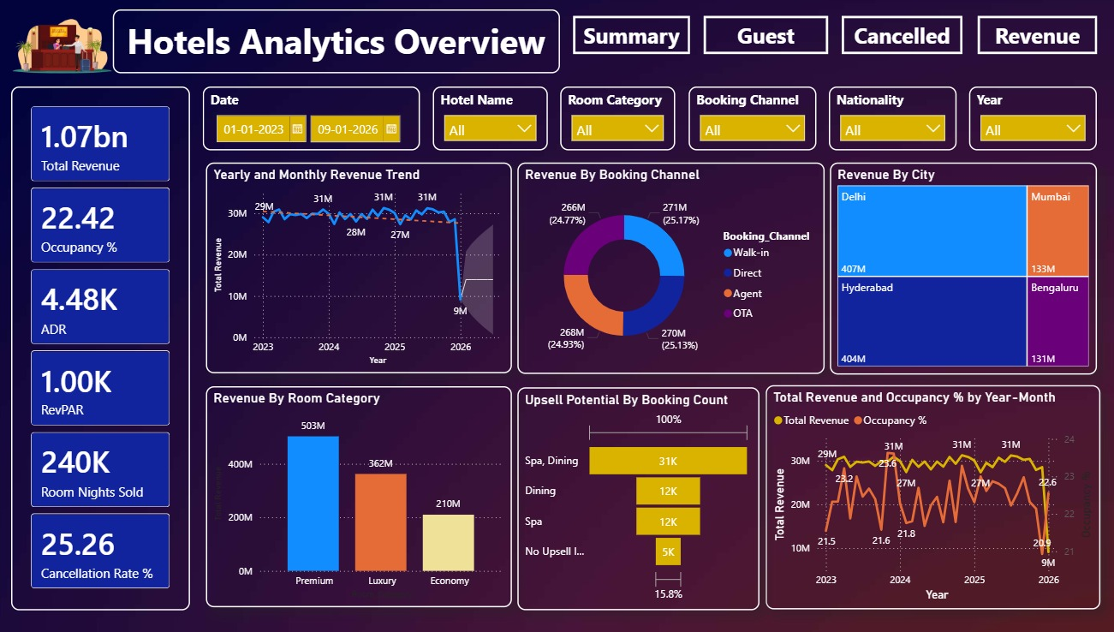
Figure1 : Dashboard Overview

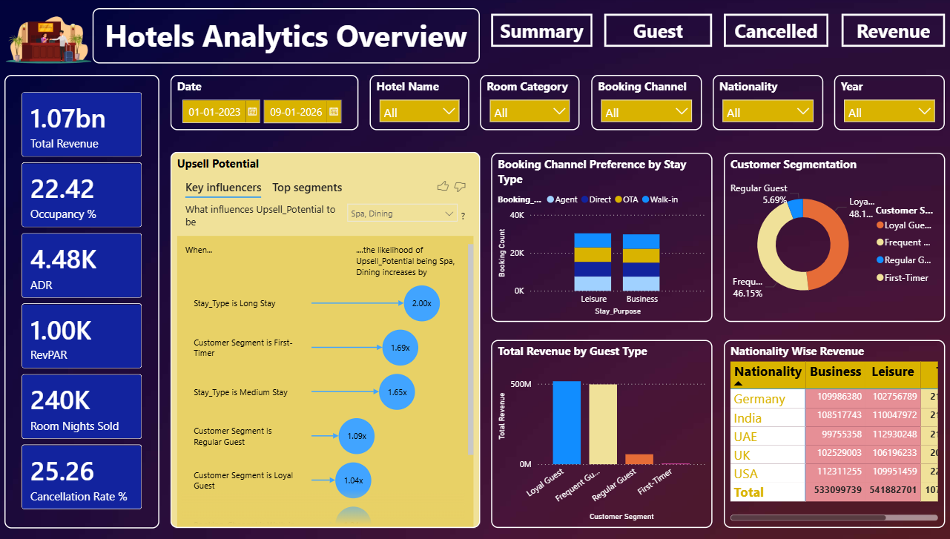

Figure 2 : Guest Analysis
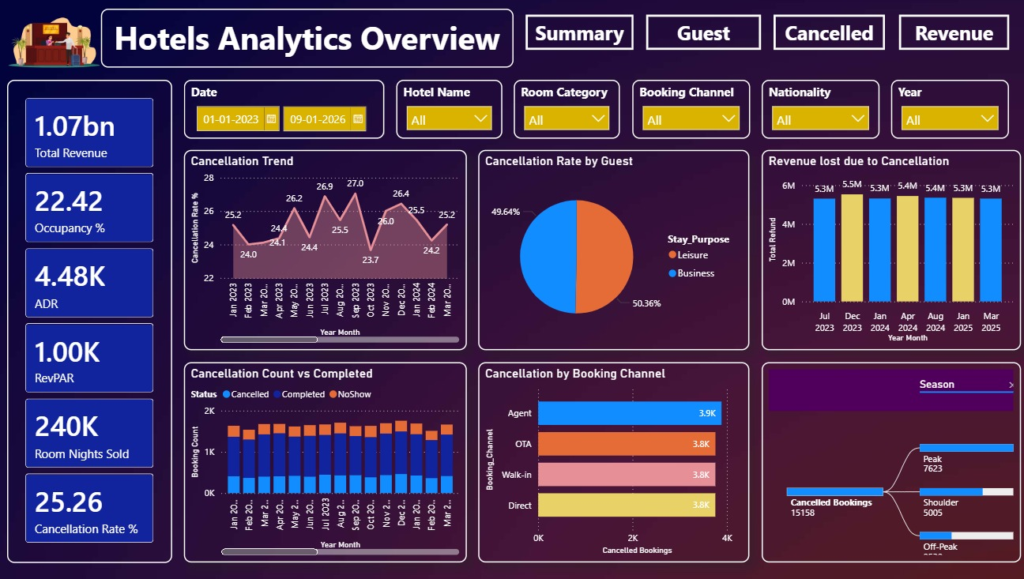
Figure 3 : Cancellation Trends

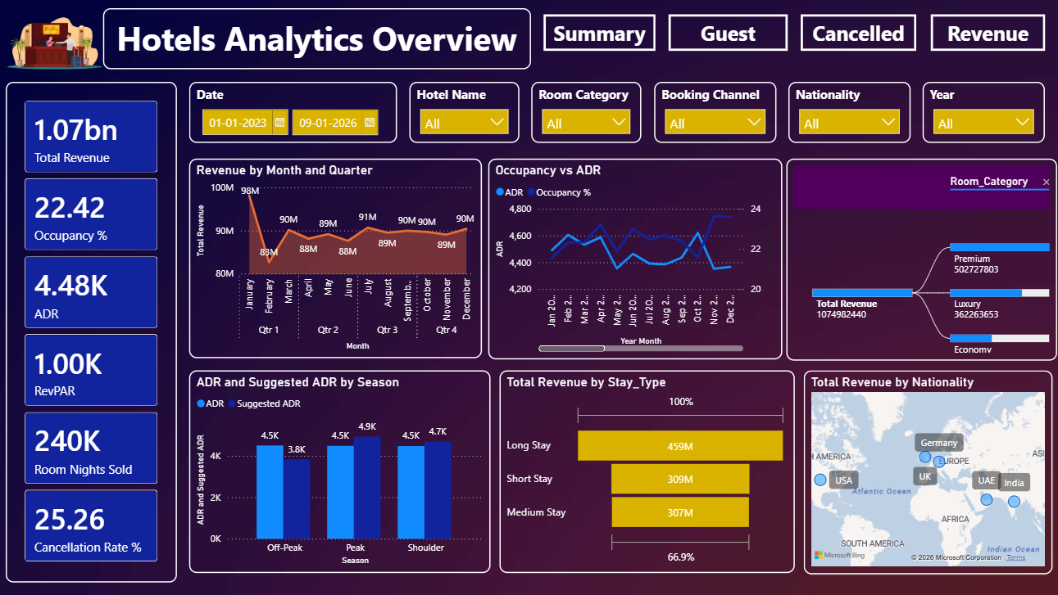
Figure 4 : Revenue Strategy Dashboard

